CS331 Project 4 Problems – Ben Webb

1. The developer would choose to use UDP over TCP when they are more interested in communicating as many packets as possible as opposed to all packets. A common example is video and audio streaming services, they need to communicate as much information as possible, but if one of the packets gets lost and a frame is dropped, that is overall better than ensuring all frames reach the user.
2. During the three-way handshake, each would share their buffer sizes. TCP messages will then be sent incrementally larger until the transmission window reaches 50 Mb. At that point the Congestion Window will be larger than the Receiver Window and the transmission window will cease to grow. Because there is a direct connection between the two and the link will never reach its bottleneck.
3. 3425 datagrams would need to be sent. I found this answer by dividing 5,000,000 by 1460 and rounding to the next largest integer.
4. {X,V,U,W,Y,T,Z}
5. Gloin: IPv4=137.146.183.16 & IPv6=fe80::da9e:f3ff:fe40. Dori: IPv4=137.146.183.12, IPv6=fe80::da9e:f3ff:fe41:f985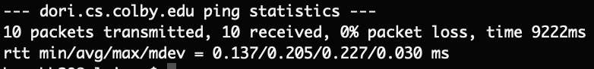

I pinged gloin and dori at multiple times throughout the day. As you can see there is not really a significant change in the RTT depending on the time of day. I assume that is because they are one hop away from each other. I confirmed this using the traceroute command.



* 1. Client: 0x892bf4c; Server: 0x5402f9d8
  2. **Done in blue.**
  3. **Done in orange.**
  4. **Done in green.**
  5. The three packets I chose were 1/2, 4/5, and 10/11. 2 is a response to 1 from the server with a RTT of 3.85 ms. 5 is a response to 4 with a RTT of 0.76 ms. 11 is a response to 10 with a RTT of 0.78 ms. I think the latency of the network is around 0.78 seconds. The first packet took a longer time to receive because it also involved exiting the LISTEN state for the server.